SENIOR PHOTO INFORMATION
Senior Pictures, Quotes, and Parent Ads are due to the yearbook no later than January 27th.
The basics for photos:
- Senior photos must be in color
- Photos must be Portrait orientation- not landscape
- Photos must be large enough so they are not pixelated when printed
- Students in photos must follow school dress code – this last one seems simple, but we regularly run into issues of dress code violations which make students need to resubmit images.
**PLEASE FOLLOW DIRECTIONS AND DO NOT SEND PHOTOS, QUOTES, OR ADS DIRECTLY TO YEARBOOK STAFF.**
More specific REQUIREMENTS:
SENIOR PHOTOS should MEET THE FOLLOWING LIST OF REQUIREMENTS FOR SIZE, CLARITY, AND POSITIONING:
THE SIZE OF THE IMAGE ON YOUR COMPUTER HAS A DIRECT CORRELATION WITH THE QUALITY OF THE IMAGE. WHEN YOU GET YOUR SENIOR PHOTOS TAKEN BY A PROFESSIONAL, THEY WILL GIVE YOU A COPY OR PERHAPS LINK TO THE ORIGINAL IMAGE. IT IS THIS FILE THAT YOU SHOULD BE PASSING ONTO US BECAUSE IT WILL STILL SHOW UP CRISP AND CLEAR WHEN WE PUT IT INTO THE YEARBOOK. THE SMALLER THE IMAGE, THE LOWER THE QUALITY, AND THE WORSE IT WILL LOOK IN THE BOOK. (IF YOU ARE UNABLE TO GET PROFESSIONAL PICTURES, THERE ARE OTHER WAYS TO GET SENIOR PICTURES TAKEN: HAVE A FRIEND WHO HAS A HIGHER QUALITY CAMERA OR PHONE TAKE ONE, AND THEN MAKE SURE THEY PASS ON THE HIGHEST QUALITY IMAGE WHEN EXPORTING OR SENDING IT TO US. IN ADDITION, THE YEARBOOK TEAM WOULD BE HAPPY TO TAKE PICTURES, BUT STUDENTS WILL NEED TO ARRANGE THAT WITH ONE OF THE YEARBOOK STAFFERS WELL IN ADVANCE OF WHEN THEY WANT TO DO THEIR PICTURES.
- JPG or PNG FORMAT AND A RESOLUTION OF 300 DPI OR GREATER.
- HEAD, FULL OR PARTIAL BODY SHOTS ARE OKAY. PLEASE MAKE SURE YOUR PHOTO IS APPROPRIATE. THE PICTURE SHOULD NOT BE FROM TOO FAR AWAY, BUT INSTEAD BE A CLOSE-UP AS THE SUBJECT WILL NOT BE VISIBLE WHEN PUT INTO THE BOOK.
- IMAGES MUST BE IN COLOR - MINIMUM 2.25” WIDE, 3” HEIGHT, AND 300 DPI PREFERRED – an image that is too small will appear pixelated.
- HEAD SIZE (TOP OF HAIR TO BOTTOM OF CHIN): MIN 1” MAX. 1.5”.
- DO NOT CUT THE HEAD/HAIRLINE AT THE TOP OF THE PHOTO.
- OUTDOOR BACKGROUNDS CAN BE USED BUT NOT SUGGESTED.
- USE OF PHOTOS WILL BE AT THE DISCRETION OF THE YEARBOOK STAFF
***PICTURES FOR THE YEARBOOK CANNOT CONTAIN WEAPONS OR DRUG/ALCOHOL REFERENCES.

SENIOR QUOTES

STUDENTS MAY EITHER WRITE THEIR OWN MESSAGE OR QUOTE SOMEONE ELSE. IF THEY CHOOSE TO QUOTE SOMEONE ELSE, THEY MUST ATTRIBUTE THAT QUOTE TO WHOM SAID IT. WE WILL NOT INCLUDE ANY QUOTES THAT DO NOT HAVE AN ATTRIBUTION OR ONES THAT ARE POTENTIALLY INAPPROPRIATE. ALL STUDENT QUOTES AND MESSAGES MUST BE ACCOMPANIED BY UPDATED PARENT CONTACT INFORMATION WITH A CURRENT PHONE NUMBER.

QUOTES INVOLVING GUNS, DRUG OR ALCOHOL REFERENCES, OR OF AN INAPPROPRIATE SUBJECT OR SOURCE WILL NOT BE ACCEPTED.

TO SUBMIT YOUR SENIOR QUOTE, ADD IT TO THE “NOTES” SECTION IN YEARBOOK SNAP YOUR SENIOR PHOTO WHEN UPLOADING.

SUBMISSION INFORMATION
We are using an APP and Website called Yearbook Snap. Below is a video link for how to use Yearbook Snap as well as the flyer from the LHS website:

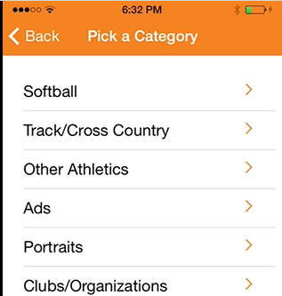
https://vimeo.com/110939899
When you get to here,
select “SENIOR PHOTOS” as the
category to submit your
senior photo. Place quote
in the notes section.
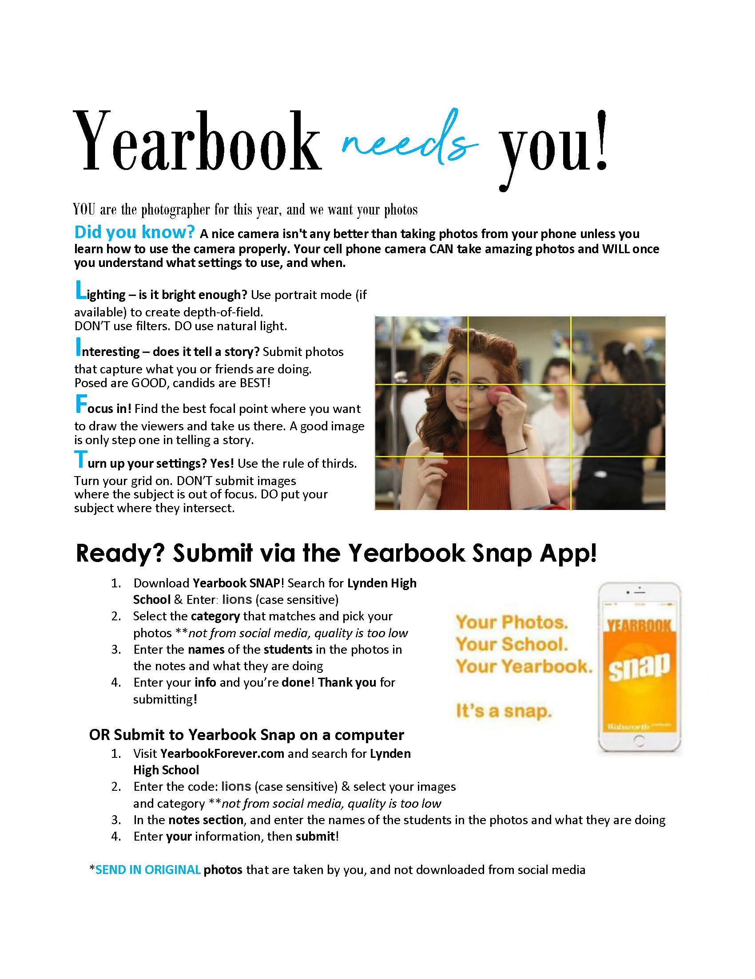
Senior ADS
We will only provide space for four ½ page ads and twenty-four ¼ page ads – or equivalent to 8 pages of ads. Senior ads are available for purchase and are first-come-first-serve as we only have limited spaces available. These can be purchased as quarter page and half page sizes.
To pay, WE NEED A CHECK MADE PAYABLE TO LYNDEN HIGH SCHOOL YEARBOOK (¼ PAGE ($65) OR ½ PAGE ($130)). THIS CHECK SHOULD BE TURNED IN TO THE MAIN OFFICE. IN ORDER TO MEET THE DEADLINE, NO ADS not paid for AND SUBMITTEDby January 27th WILL BE ACCEPTED, SO MAKE SURE TO GET YOUR payment and ads submitted ASAP!!!

REQUIREMENTS:
SENIOR ADS NEED TO MEET THE FOLLOWING LIST OF REQUIREMENTS FOR SIZE, CLARITY, AND POSITIONING:
TWO WAYS TO SUBMIT A SENIOR AD/REQUIREMENTS:
1. WE WOULD PREFER FOR PARENTS TO CREATE THEIR OWN AD GIVING THEM THE ABILITY TO MAKE IT EXACTLY AS THE PARENT PICTURES IT, UNDERSTANDING THAT THE CONTENT NEEDS TO BE APPROPRIATE FOR BEING PUBLISHED WITHIN A SCHOOL YEARBOOK.
YOU CAN MAKE THIS IN A SERIES OF COMPUTER PROGRAMS OR APPS: MICROSOFT WORD (EXPORT THE DOCUMENT AS A PDF), PAINT, ADOBE ACROBAT, PHOTOSHOP, PAGEMAKER, ETC.
YOU COULD ALSO DO THIS ONLINE AT PLACES LIKE: LUCIDPRESS.COM or an app like Canva (iOS). IF YOU CHOOSE THIS OPTION, FOLLOW THE DIRECTIONS BELOW.
- CREATE A NEW BLANK DOCUMENT
- SELECT CUSTOM UNDER SIZE AND ORIENTATION, AND INPUT APPROPRIATE SIZE FOR THE AD YOU WOULD LIKE: HALF PAGE - 7 1/2 X 4 1/2 (2250X1350 PIXELS) "LANDSCAPE" ORIENTATION - QTR. PAGE - 3 1/4 X 4 1/2 ( 975X1350 PIXELS) "PORTRAIT" ORIENTATION
- AFTER YOU HAVE COMPLETED THE AD, GO TO FILE AND DOWNLOAD AS: SELECT PNG OR JPG, TITLE, AND THEN UPLOAD TO DROPBOX WITH THE LINKS ABOVE.
- ABOVE DIMENSIONS ARE VERY IMPORTANT! YOUR AD CAN BE PROPORTIONATELY LARGER THAN THESE BUT NOT SMALLER.
- SHARE WITH SOLTMANK@LYNDEN.WEDNET.EDU.
2. YEARBOOK STAFFERS CAN ALSO CREATE THESE ADS FOR YOU, BUT THEY WILL FOLLOW A SIMPLER AND MORE DIRECT FORMAT. FOR THESE, YOU WILL NEED:
- A TYPED PARENT MESSAGE OF 75 WORDS OR FEWER—PLEASE INCLUDE YOUR NAME AS WELL AS YOUR STUDENT’S NAME.
- ONE OR TWO FAVORITE PHOTOS OF YOUR GRADUATE. MAKE SURE YOU LABEL YOUR PHOTOS WITH FIRST AND LAST NAMES ON THE BACK. PLEASE WRITE THE NAMES ON A STICKER/LABEL OR PIECE OF TAPE. IF POSSIBLE, PLEASE DO NOT WRITE ON THE PHOTOS THEMSELVES. ALSO MAKE SURE THAT PHOTOS ARE PROTECTED BY SOME SORT OF PLASTIC COVERING OR ENVELOPE. ALL PHOTOS WILL BE RETURNED BY THE END OF THE YEAR.
​​

